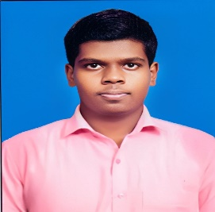 **KISHORE S**

**B.SC (CS) UNDERGRADUATE**

**CONTACT DETAILS:**

**Phone:** +91 8637617688

**E-mail:** [contact.kishores@gmail.com](mailto:contact.kishores@gmail.com)

**Location:** Chennai, TN 600 082

**ACHIEVEMENTS:**

* Won 3rd Prize in 5G Workshop Presentation Competition.
* Appreciated for conducting seminar on Google Application on Cloud-computing.

**TECHNICAL SKILLS:**

* PYTHON 
* JAVA 
* HTML 
* FIGMA 
* DJANGO 
* BOOTSTRAP 
* CSS 
* JAVASCRIPT 

**SOFT SKILLS:**

* Hard-worker
* Logical Thinking
* Team Player
* Self-Learner

**LANGUAGES:**

* English
* Tamil

**SUMMARY:**

Currently an undergraduate Computer Science student from Madras University. Seeking a position in a reputable organization to utilize my academic background and skills. My immediate goal is to enhance my knowledge and skills by delivering my best, adapting to new environments, and meeting organizational expectations. I believe in dedication, reliability, and making meaningful contributions in every role I undertake.

**EDUCATION QUALIFICATION:**

**C KANDASWAMI NAIDU COLLEGE FOR MEN’S - B.SC (COMP.SC.),**

**Anna Nagar, Chennai.**

**2020-2023**

**Pass Percentage – 75 % (Till 5th Semester)**

**PERIYAR MAT HR SEC SCHOOL., Periyar Nagar, Chennai**

**2018-2020**

**Pass Percentage -** HSC **- 76 %**

**2016-2018**

**Pass Percentage-** SSLC – **65 %**

**--------------------------------------------------------------------------------------------**

**PROJECTS UNDERTAKEN:**

* To develop web application in Python using Django.
* Creating simple HTML for front end development.
* Integrating HTML and CSS files with existing application
* Developed a basic version of Sign Language Detection and Translation system with python using Pycharm software.

**PART TIME WORK EXPERIENCE:**

**Data Entry Operator**

**Raven & Co., (Audit Firm), Chennai**

* Data processing of Bank entries.